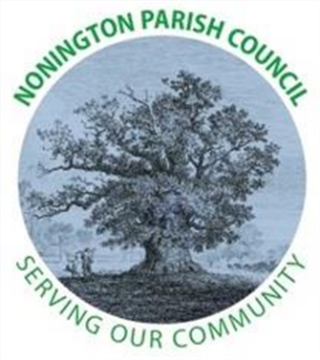

NONINGTON PARISH COUNCIL
Email: noningtonparishclerk@outlook.com Website: www.noningtonpc.org.uk

TO: ALL MEMBERS OF NONINGTON PARISH COUNCIL
Councillors are hereby summoned to attend an Ordinary Meeting of the Council to be held on
Wednesday 2nd April 2025 at 7.00pm in Nonington Village Hall

A G E N D A

- Chairman’s Welcome and Apologies for absence

- Declarations of Interest

- Confirmation of the Minutes of the Ordinary Meeting held 5th February 2025

- Public Forum

- Report from Councillors

  - Cllr Manion
  - Cllr Woodgate
  - Cllr Pout
  - Cllr Mamjam

- Finance
To be filled in when gain access to banking

- Planning

- Highways and Footpaths

- Playground, Field and Pond

- Items for discussion not on the agenda

- Date of the next meeting: Wednesday 2nd April 2025

