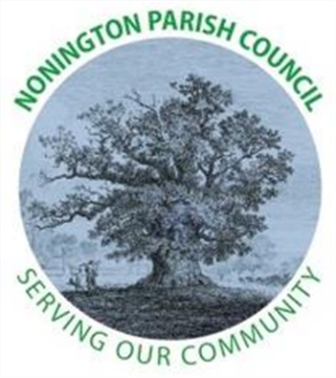
NONINGTON PARISH COUNCIL
Minutes of the Meeting of the Council - Wednesday 5th February 2025 at 19:00

Present: Cllr Louisa Jarred (Chairperson); Cllr Julia Plumptre (Vice-Chairperson); Cllr Clare Delf; Cllr Jane Vurley; 10 Members of the Public; Mr Gerry Worthy (Clerk) and Cllr Steve Manion (KCC).

- Apologies and approval of absences: Cllr Jarred welcomed everyone present and thanked them for attending the meeting. Cllr Jarred and Committee thanked Cllr Woods for her dedication and assistance as Clerk as Cllr Woods stepped down. No apologies were received

- Declarations of interest: none were received.

- Minutes of previous meetings: The minutes of the meeting held on Wednesday 22nd January 2025 was approved as true a record, proposed by Cllr Delf, seconded by Cllr Vurley. Signed by the Chairperson.

- Public Forum: Members of the Public in attendance were afforded the opportunity to ask a question or make a statement.
- Cllr Manion discussed Devolution of Local Government and the fact Kent will not be part of County Programme. Elections and re-organisation will progress as previously.
- New litter bin at Malthouse. Clerk to speak to DDC – in progress
- Mike Tapp – clerk to write to him about bus service in village – Not complete
- Height of new house being built on Easole Street is still ongoing. Cllr Delf spoke to DCC and although deemed to violate planning application wasn’t deemed to have great impact and no further action would be taken.
- New bin to be installed; £285 cost, £110 install and £190 emptying charge/annum. Cllr Jarred recommended to be voted and decided at next meeting

- Finance:
- Payments and Receipts: Bank Balance as of 2nd February 2024: £647.04 (Current Account) and £18,210.12 (Savings Account) = Total £18,857.16
Payments
Hugo Fox – Monthly Website Costs (Jan 24) - £11.99
Unity Trust Bank – Service Charge - £6.00
Stephanie Woods – Clerk Salary (Jan 24) - £380.14
HMRC – Clerk PAYE - £293.60
Stephanie Woods – Final Salary - £71.15
The above payments were proposed by Cllr Plumptre and seconded by Cllr Vurley. ALL AGREED.
- Planning
None to discuss.

- Highways and Footpaths
It was raised that during the icy cold weather there has been no gritting by KCC. Cllr Manion to see if they can add to gritting routes.
The salt bin by school is full of water. Clerk to report to KCC Highways and get them to refill with salt.

- Playground, Field and Pond
Hedges and lawn costs to be updated; clerk to obtain 3 quotes.
Trees need to be trimmed, priority due season and nesting birds; clerk to obtain 3 quotes.
Playground needs risk assessment and maintenance
Leaves on footpath on Holt Street was raised. Clerk to report to DDC – has been requested

- Items for discussion not on the agenda
- Litter pick – 8th March 2025. Clerk to book with DDC and speak to Beach Grove.
- Member of public highlighted state of repair and rubbish surrounding the former “Royal Oak” Public House. It was explained that ongoing works still being undertaken. Councillors said they would investigate site in daylight.
- New salt bin in Easole Street – Clerk to request from DCC
- Dirty nappies and cigarette ends littering hedge and area by school – Cllrs to notify school
- Torchlight charity Concert on 21st February 2025
- Gardening Flower Show, variety of classes on 29th March 2025 – Barry from Gardening club putting schedule together

- Date of the next meeting: Wednesday 5th March 2025 at 7pm in Nonington Village Hall

There being no further business, the meeting was closed to the public at 19:30.

Please note these Minutes remain as draft until they are approved by the Parish Council at their next meeting on 5th February 2025.

