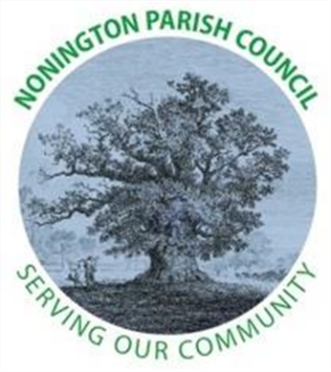

NONINGTON PARISH COUNCIL
Email: noningtonparishclerk@outlook.com Website: www.noningtonpc.org.uk

TO: ALL MEMBERS OF NONINGTON PARISH COUNCIL
Councillors are hereby summoned to attend an Ordinary Meeting of the Council to be held on
Wednesday 2nd April 2025 at 7.00pm in Nonington Village Hall

A G E N D A

- Chairman’s Welcome and Apologies for absence

- Declarations of Interest

- Confirmation of the Minutes of the Ordinary Meeting held 5th March 2025

- Public Forum

- New litter bin at Malthouse - Update
- Salt Bins – Update
- Litter around school - Update
- Green Day - Update
- St Mary’s Close – Update
- VE/VJ Day Celebrations
- Spring Show – Gardening Club, 29th March 2025
- Speed Monitoring Status
- Queries from members of public
- Easter Egg Hunt
- Vacancies on Parish Council (2)
- Grants

- Finance
To be filled in when gain access to banking

- Planning
- Ref: 25/00133 - Land West Of Aylesham Road And South Of, Spinney Lane, Aylesham,

- Highways and Footpaths

- Playground, Field and Pond
- Volunteer day - working group for garden clearance around pond

- Items for discussion not on the agenda

- Date of the next meeting: Wednesday 7th May 2025

