NONINGTON PARISH COUNCIL

PLANNING APPLICATION 21/01615

Transport Statement

The bus services described are no longer operating as described and indeed are now mostly absent.
The Sandwich Road within 150m to the East of the site has seen one fatal accident, one severe injury and at least two minor accidents in the last 5 years.
There has also been a fatality in Holt St just 200 yards from Snowdown station.
Other incidents are recorded on the Nonington PC website using this link:

Traffic incidents - Nonington Parish Council - Nonington Parish Council, Nonington, Dover (noningtonpc.co.uk)

Traffic through the village has increased extensively due to other developments in surrounding villages including the increase in waste lorries going to and from the enlarged waste facility in Aylesham. The average traffic count through the village is almost 1200 per day and the attached data shows the majority of traffic is speeding .

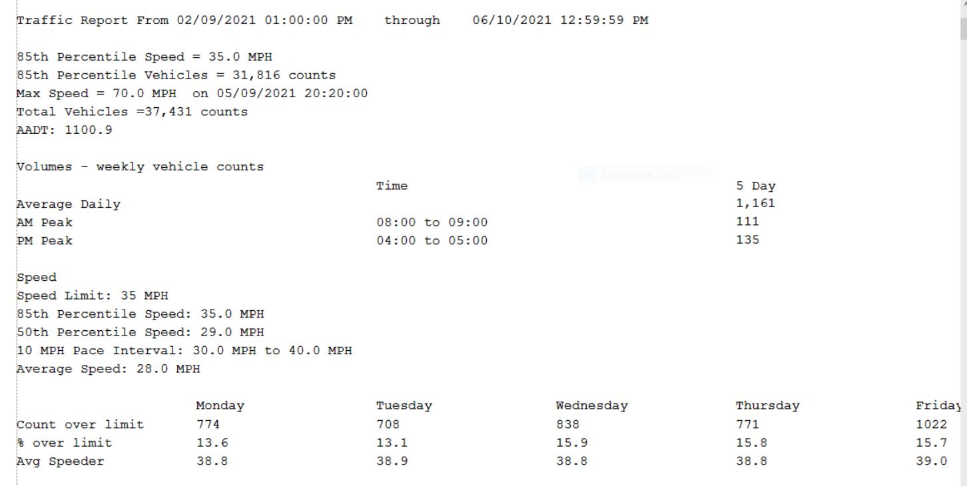

As has been well documented by other objectors the transport report has several inaccuracies particularly bus routes and timings.

We would invite members of the planning committee to walk from the proposed site to the village hall, only a 300 yards, yet on a most dangerous corner that has seen may near misses in the past and where 2 large size vans cannot pass each other due to the road width. There are no footpaths on this stretch of road. Southdown Cottage, which is on the bend, has had its fence down twice. Further traffic would only make things worse and anyone walking from the proposed development would have to negotiate this road.

Site traffic is very limited and certainly far less than 29 new houses would generate.

Trains are not 2 per hour but only hourly.

