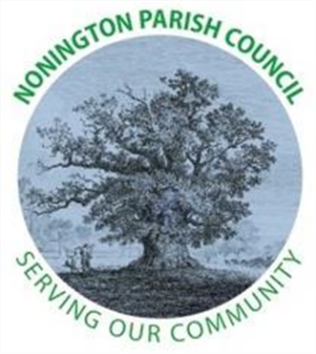
NONINGTON PARISH COUNCIL
Minutes of the Meeting of the Council - Wednesday 5th March 2025 at 19:00

Present: Cllr Louisa Jarred (Chairperson); Cllr Julia Plumptre (Vice-Chairperson); Cllr Clare Delf;
18 Members of the Public; Mr Gerry Worthy (Clerk) and Cllr Manion.

- Apologies and approval of absences: Cllr Jarred welcomed everyone present and thanked them for attending the meeting. Apologies were received from Cllr Vurley and Cllr Pout.

- Declarations of interest: none were received.

- Minutes of previous meetings: The minutes of the meeting held on Wednesday 5th February 2025 was approved as true a record, proposed by Cllr Delf, seconded by Cllr Plumptre. Signed by the Chairperson.

- Public Forum: Members of the Public in attendance were afforded the opportunity to ask a question or make a statement.
- Cllr Manion discussed Devolution of Local Government and the fact Kent will not be part of County Programme. No further update.
- New litter bin at Malthouse. Agree location and take photos.
- Mike Tapp – clerk to write to him about bus service in village – Not complete
- Height of new house being built on Easole Street is still ongoing. Cllr Delf spoke to DCC and no further action would be taken.
- Salt bins – New bin Clerk has raised case with KCC, case #863895, other opposite pub Clerk has raised case with KCC, case #863898. Clerk will check for update as 28 days to action.
- Litter at school; Cllr Vurley to speak with school concerning cigarette ends and dirty nappies.
- Royal Oak Public house – Litter and state of repair being tidied over the next few days.
- Green Day - this coming weekend. Monitor collection of litter and report back to DDC of issues and escalate.
- St Mary’s Close – steps down path to access station never appear to be cleared. Public volunteer will monitor and clear, bag in black sack and leave for collection.
- Spring Show – Gardening club in 8th year being held in Village hall on 29th March 2025. All encouraged to participate and enter. Leaflets distributed and be placed on noticeboards.
- 80th anniversary of VE and VJ day what is the Parish doing as a collective?
  - Barnabus asked if can be linked with Picnic in the Park?
  - Church running a service on Sunday following VE day (Thursday)
- Speed Monitoring Camera – questioned whether speed detection was accurate before batteries failed? Needs verifying prior to confirmation of replacement order (batteries and charger unit)
- Potholes – in Vicarage Road all way down, not yet reported. Cllr Jarred mentioned can be reported online by members of the Public with KCC on their app.
- Road closure signs and diversion route is confusing.

- Report from Councillors:
None Received

- Finance:
- Payments and Receipts: Bank Balance as of 2nd February 2024: £647.04 (Current Account) and £18,210.12 (Savings Account) = Total £18,857.16
Payments
Still no access therefore no updates at this time.

- Planning
None to discuss.

- Highways and Footpaths
- The salt bin by school is full of water. Clerk reported to KCC Highways and get them to refill with salt. Case #863898.
- New Salt bin requested from KCC on Easole Street; case #863895.
- St Mary’s Close – steps down path to access station never appear to be cleared. What is the process? As 70% of homes are private.

- Playground, Field and Pond
- Hedges and lawn costs were agreed to continue now that revised rate card been received and start of maintenance season. Will be reviewed at close of maintenance season.
- Trees, field and pond need assessment in daylight and was proposed to review on Green day, and draw up improvement plans and go to tender. Encourage public to improve area, encourage wildlife, children, insects etc. Gather ideas, points of view and bring back to Parish Council.
- Playground needs risk assessment and maintenance

- Items for discussion not on the agenda
- Cllr Jarred mentioned that Nonington Parish Council currently has two Councillor vacancies. One has been formally advertised online and within noticeboards around the village. Will close in 14 days’ time. Those interested are urged to reach out to the Parish Council.

- Date of the next meeting: Wednesday 2nd April 2025 at 7pm in Nonington Village Hall

There being no further business, the meeting was closed to the public at 19:30.

Please note these Minutes remain as draft until they are approved by the Parish Council at their next meeting on 2nd April 2025.

